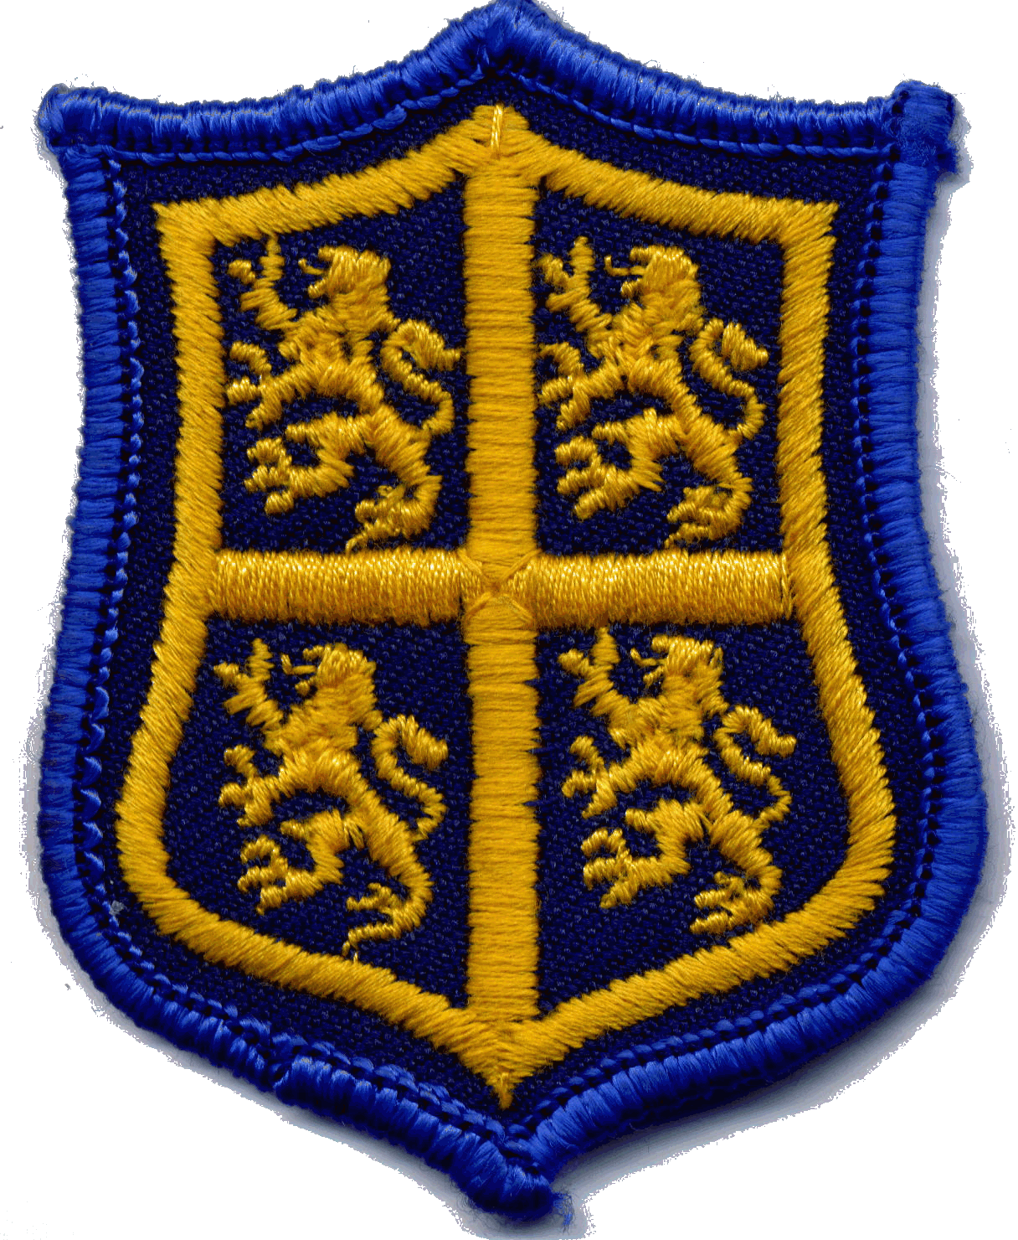

Durham County Ladies’ Golf Association

Safeguarding and Child Protection Policy

The Intention of the Policy

Durham County lady golfers act as role models for young girls and therefore it is crucial that they develop an environment of care, patience, understanding and encouragement in which junior golfers can excel.
As such they will be responsible for protecting children from all forms of abuse and discrimination and for ensuring that they receive equal treatment regardless of age, race, sex, culture, religion, language or ability.
Durham County Ladies Golf Association (DCLGA) will therefore endeavour to ensure the safety and protection of all participating junior girls through the Child Protection guidelines adopted by the Management Committee.

A Vision of Durham County Junior Golf

By providing a safe and caring environment in which children’s welfare is always paramount DCLGA will ensure their junior girls will have the best possible introduction to the game of golf which will create a life long interest and love of the game.

Policy Aims

- To provide children with appropriate safety and protection whilst in the care of DCLGA Junior Section and also help them to enjoy their experience of the sport.
- To reassure parents that their children will receive the best practicable care possible whilst participating in activities within the club.
- To provide support to staff and volunteers to make informed and confident responses to specific child protection issues and to fulfil their role effectively.

Principles

- The welfare of children is paramount.
- Be aware of the needs of every stage of a youngster’s development and ability and provide activities within the sport that are appropriate and relevant. Encourage and promote an understanding of the ethos of fair play which enables friendship, respect for others and always playing within the true spirit of the game.
- All children, whatever their age, culture, gender, language, disability, ethnic origin and religious beliefs have the right to protection from abuse.
- All suspicions and allegations of abuse and poor practice will be taken seriously and responded to swiftly and appropriately. Hence developing relationships of integrity and trust with the youngsters in order to promote and enhance pupils’ self-esteem.
- All staff and volunteers working in golf have the responsibility to report concerns to the DCLGA Welfare Officer.
- Adults - staff, volunteers, coaches, referees and members will be supported to understand their role and responsibility with regard to the duty of care and protection of children and young people.
- Individuals will receive support through education and training to be aware of and understand best practice and how to manage any welfare or child protection issues that might come to light.

The Development of this Policy

DCLGA policy and procedures are based on the above principles and UK legislation and government guidance and take the following into consideration:

- The Children’s Act 1989 and 2004
- The Data Protection Act 1994 &1998
- The Police Act 1997
- The Human Rights Act 1998
- The Protection of Children Act 1999
- Caring for the young and vulnerable – Home Office Guidance for preventing the abuse of trust 1999
- The Criminal Justice and Court Services Act 2000
- What to do if you are worried a child is being abused 2005
- Working Together in Safeguard Children 2006
- The UN Convention on the rights of the Child
- Any subsequent legislation relating to child protection would implicitly be incorporated into this document

It will continue to evolve as a result of:-
a). Consultation with the Golf Foundation, England Golf representatives; Durham County Golf Partnership; any additions to the Children in Golf document and any further government legislation.
b). Any relevant consultation with Durham County Golf Club’s Health and Safety Committees.
c). Consultation with the DCLGA Committee.
d). Consultation with the members responsible for promoting junior golf within Durham County.
e). Consultation with parents to review and implement child protection and welfare procedures.

Responsibilities and Communication

- DCLGA Child Protection Policy will be available to all members, parents, staff, volunteers and participants.
- The policy will be reviewed every three years by the Management Committee and amended as appropriate. Guidance from golf’s governing bodies will be sought as part of the review process.
- The Management Committee has responsibility for ensuring that the policy and procedures are implemented, including taking any appropriate disciplinary action necessary.
- The DCLGA Welfare Officer has responsibility for responding to any allegations, concerns or child protection incidents, passing information to the appropriate National Governing Body Lead Child Protection Officer and informing the appropriate association /club staff.
- Parents have a responsibility to work together with the club in implementing procedures and providing their children with the necessary information to safeguard themselves.

Date of Adoption by DCLGA …………27th February 2012………………………

Date of the Next Review………………February 2015……………………………………

